Sprint 2 Review

**Team: Scrum of the Earth**

**GitHub:** [**https://github.com/RMIT-SEPT/majorproject-7-tues-14-30-7**](https://github.com/RMIT-SEPT/majorproject-7-tues-14-30-7)

**REVIEW:**

**The Sprint Goal was:**

* Progress towards minimal viable product by extending upon prior classes and functions, and connecting the backend features to basic front end pages. Further focus on the initial features for the project will be the fastest way to create a minimal viable product that can be extensible enough to add the other requirements.

**Status Overview:**

Assigned tasks for the Sprint were:

* Dashboard On Login (28)
* Home Page (32)
* New “Customer” User (38)
* View Business Page (47)
* View Worker Profile Page (52)

Some blockers were encountered while working on this Sprint, and so while the goal of extending upon prior features and extending functionality from the first Sprint was achieved, there is still work to be done on the assigned task in later Sprints.

**Sprint Statistics**

* This Sprint had an estimated story point value of 40, the same as the previous sprint, as the same user stories were assigned. With a conversion of 1 hour per point, an estimated 40 hours of work was required to fully complete the Sprint. For many this project required unfamiliar languages, and so additional learning was required to begin. The following burn-down chart was produced this Sprint:

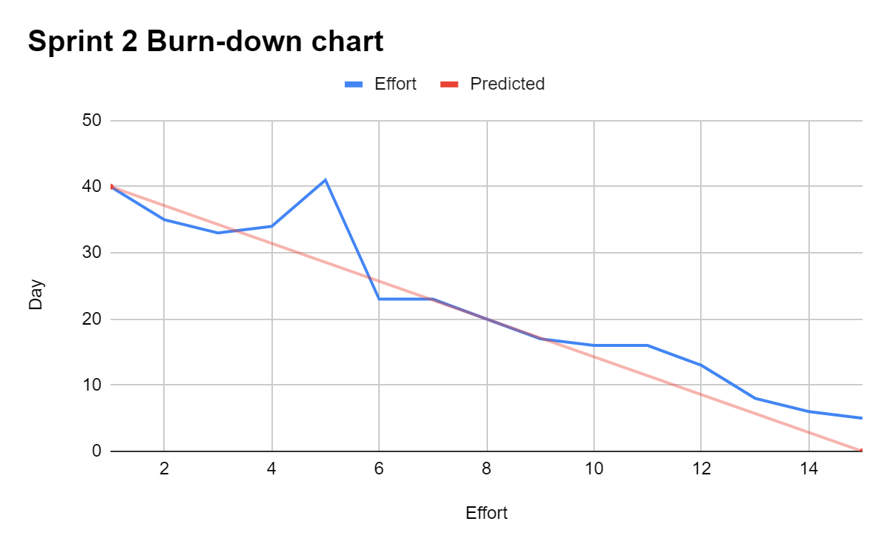

* The burn-down chart shows a steady decline over the first few days following the predicted line, with a spike around day 5 when blockers were encountered, increasing the estimated effort required to complete the sprint. From the 5th day onwards effort required followed the predicted line, however work was still required at the end of the Sprint, and thus these tasks will be included in the next one.